20.1.21 (reasoning/fluency)
L/O: Can I complete empty box equations?
I know the commutative law.
I understand how to partition a two-digit number.
I can use equipment and/or jottings to help me to find the missing number.

Use jottings to solve these problems.

1. | 10 + |  | = 20
2. | 40 + |  | = 60
3. | 20 + |  | = 70
4. | 80 - |  | = 20
5. | 90 - |  | = 30
6. | 70 - |  | = 40

Convince me:
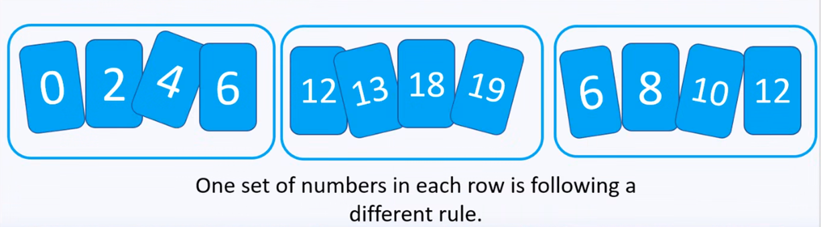
Explain which set of numbers is different and why:
____________________________________________________________________________________________________________________________________________________________________________________________________________________________________________________________________________________

