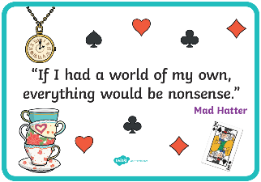
Thursday 4th March 2021
L/O: Can I create my own character and fantasy world?
I can create my own character and fantasy world.
I know how to use adjectives to describe.
I understand how to use my imagination to create a setting.

In the box below, we are going to create our own ‘monster’ or character for our scene. You will then label this character with adjectives to describe it.

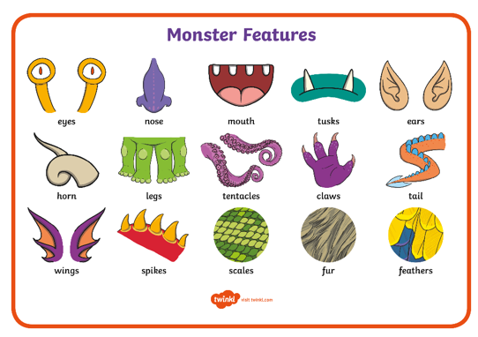
Describe your fantasy world
The trees would be made of ____________________________
_________________________________________________.

Bridges would be built from ____________________________
_________________________________________________ .

The river would be filled with ___________________________
_________________________________________________ .

Houses would be made of _______________________________
__________________________________________________ .

Draw your fantasy world below.

