19.04.21 Year 1 spellings Mrs Goodwin’s group
 | Practise 1 | Practise 2 | Practise 3 | Practise 4 | Practise 5
fright
light
night
might
coat
foal
toad
boat
This week we are learning the igh and oa sounds.

19.04.21 Year 1 spellings Mrs Goodwins’s group
 | Practise 1 | Practise 2 | Practise 3 | Practise 4 | Practise 5
fright
light
night
might
coat
foal
toad
boat
This week we are learning the igh and oa sounds.

high
light
night
might
fright
tight

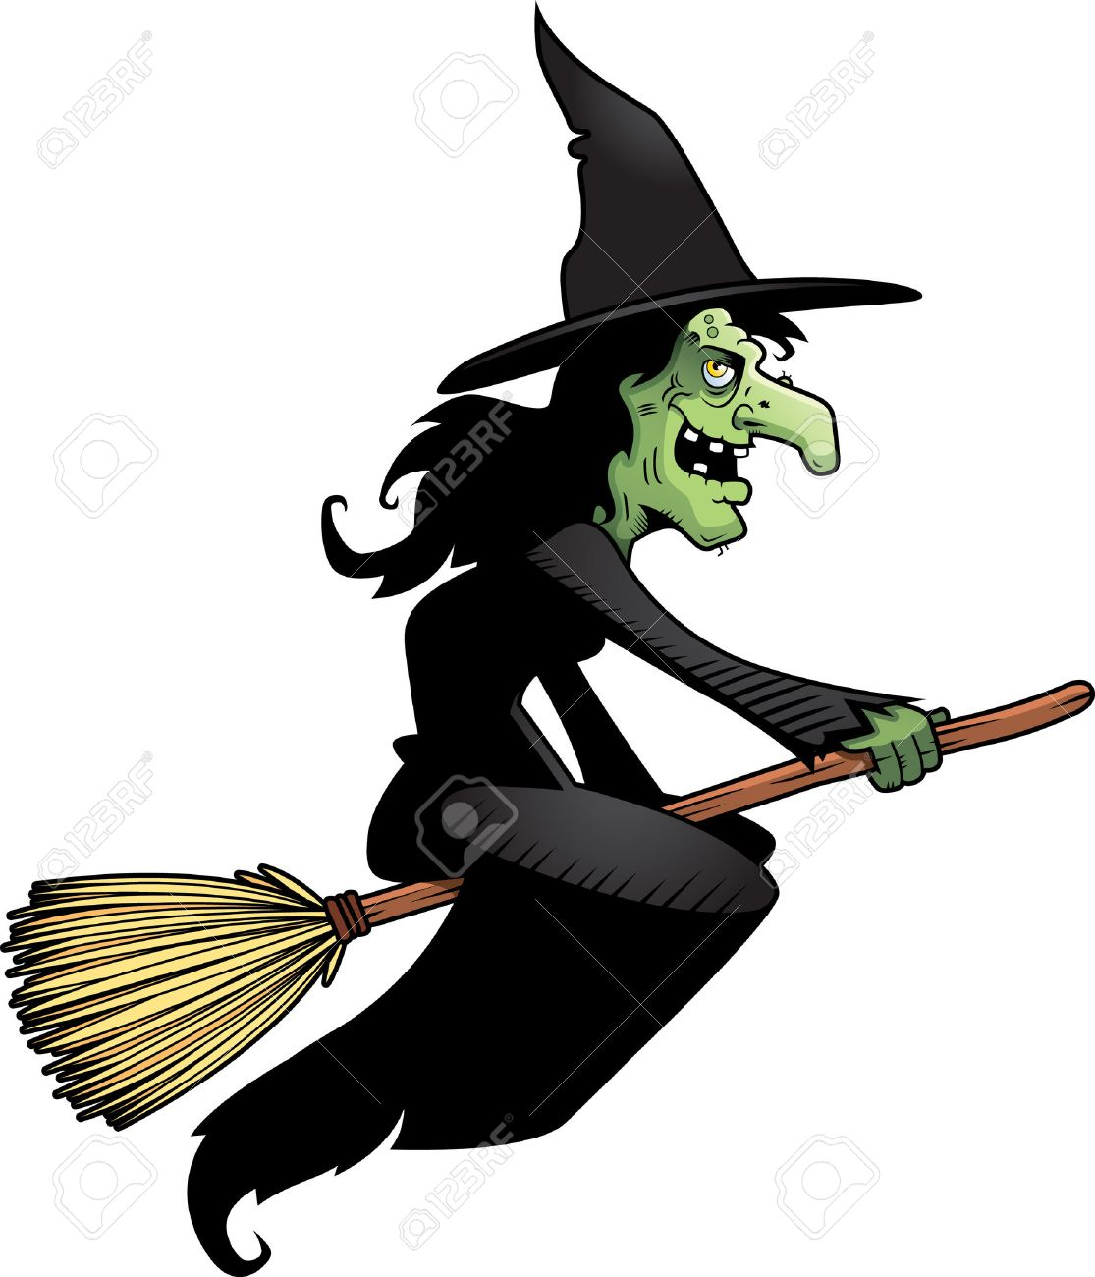
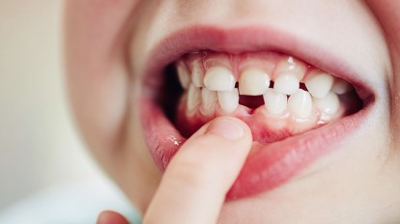
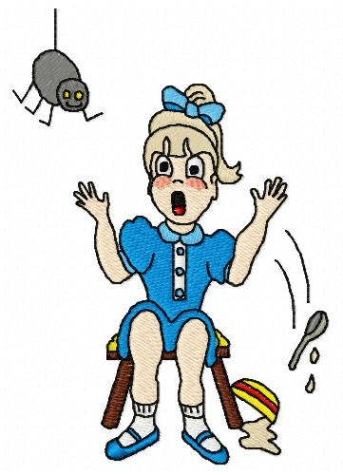
clight
brighg
trighb
shighp
thrigh

coat
foal
toad
boat
goat
toast
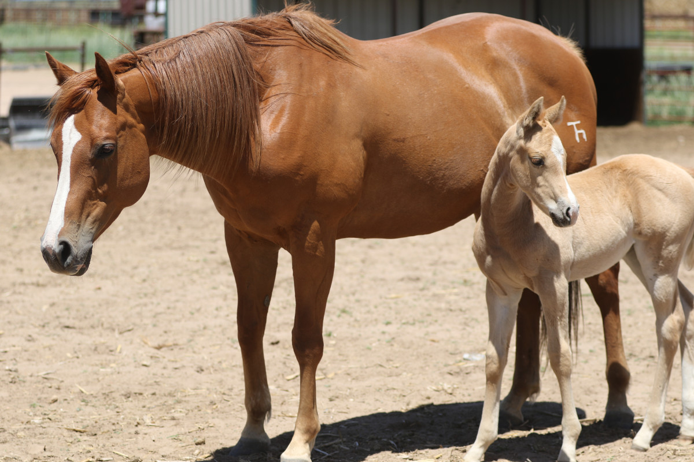

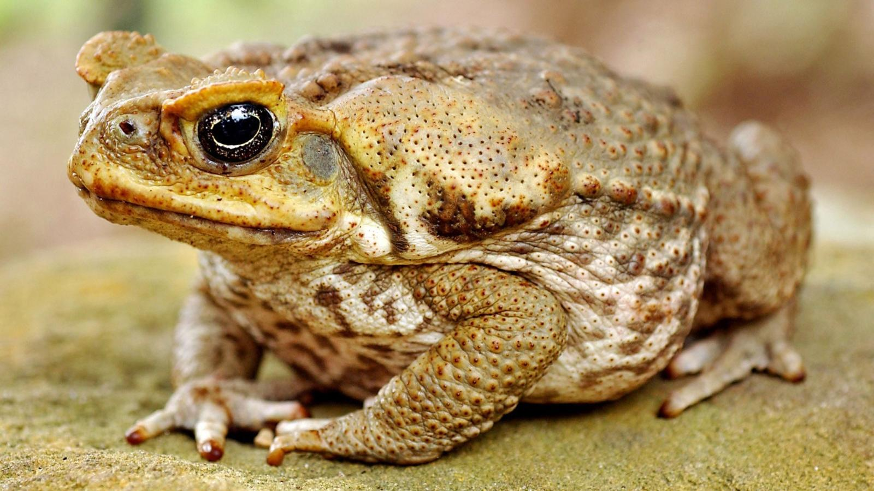

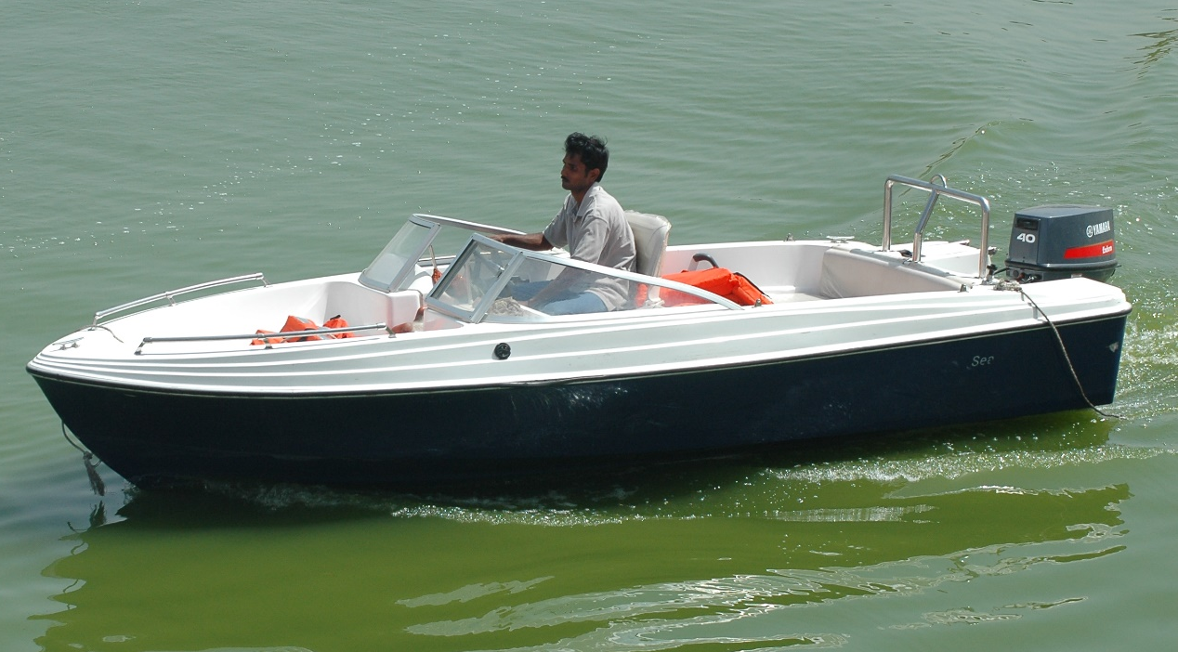

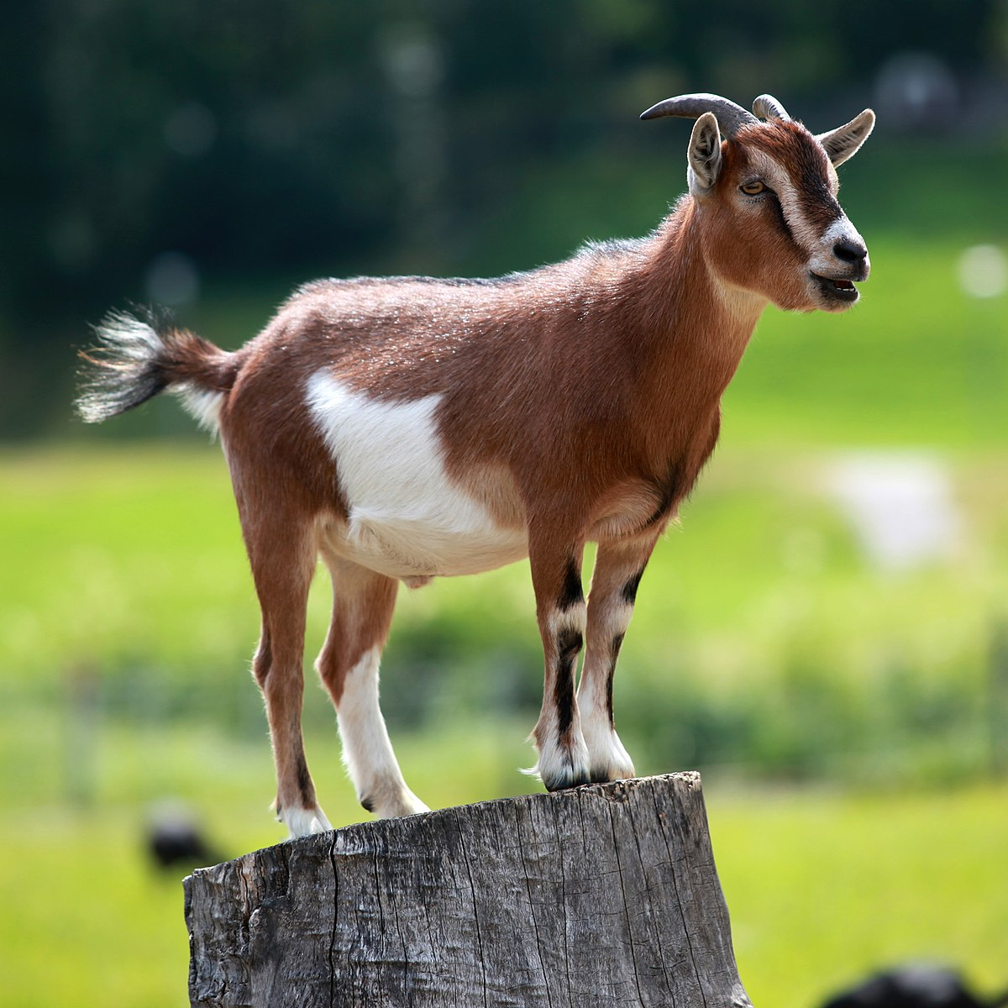
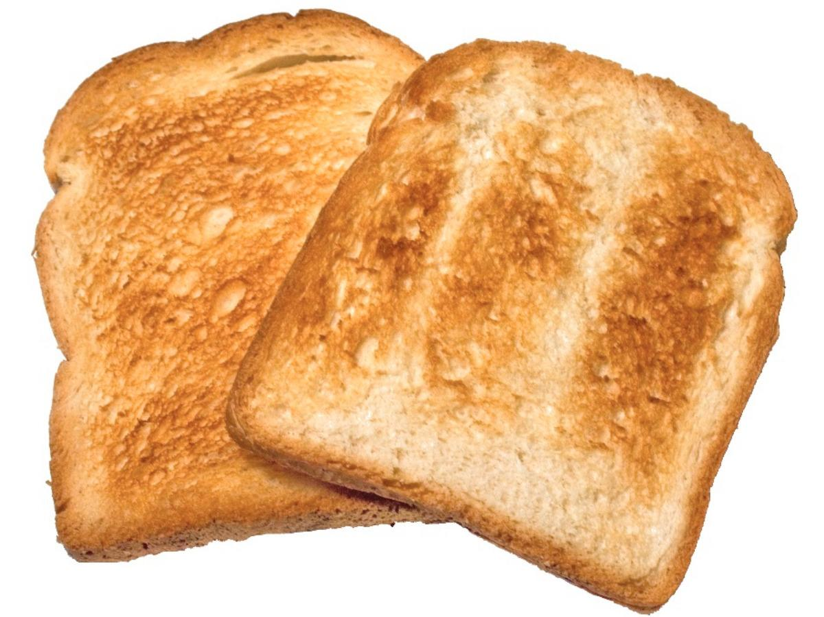
coat
foal
toad
boat
goat
toast
quoab
floap
croan
broaf
poazz
hoach

