8.1.21
L/O: Can I collect data to create a pictogram?
Task 1
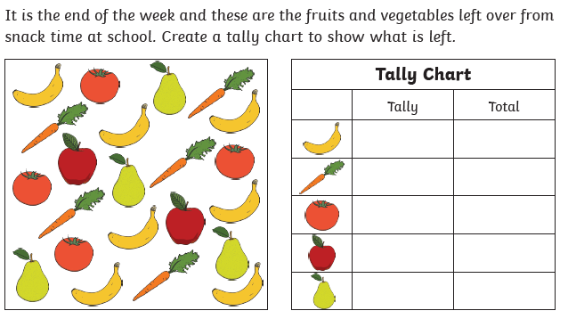

Task 2
