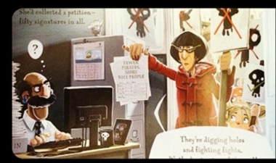
Friday 8th January 2021
L/O: Can I write a letter in the first person?
Pretend you are one of the annoyed neighbours from the story. Write a letter to complain about the mischievous pirates.

Mr Annoyed Neighbour
Sunny Street
Dull-On-Sea
Mr Bishop
Town Hall
Dull-On-Sea
8th January 2021

Dear Mr Bishop of Dull-On-Sea Council,

I am writing to tell you about _______________________________________________
______________________________________________________________________________________________________________________
_________________________________________________________________________________________________________________________________________________________________________________
______________________________________________________________________________________________________________________
______________________________________________________________________________________________________________________Yours Sincerely,
___________________________

