15.1.21 (reasoning/problem solving)
L/O: Can I solve a magic square problem?
I understand how to add and subtract 10 to any number.
I know how to find a starting point.
I can mentally add and subtract numbers.

Starter – add and subtract 10 to any number
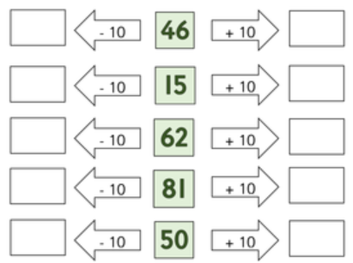

What is the value of each symbol?
=
=
=
=

 |  |  | 30
 |  |  | 20
 |  |  | 23
25 | 28 | 20

What is the value of each symbol?
=
=
=
=
=

 |  |  | 25
 |  |  | 19
 |  |  | 18
24 | 21 | 17

Super Challenge!
What is the value of each symbol?
=
=
=
=
=
= 6

 |  |  |  | 22
 |  |  |  | 16
 |  |  |  | 17
 |  |  |  | 14
18 | 12 | 19 | 20

