13.1.21 (Problem solving and reasoning)
L/O: Can I interpret data from pictograms and bar charts?
1.
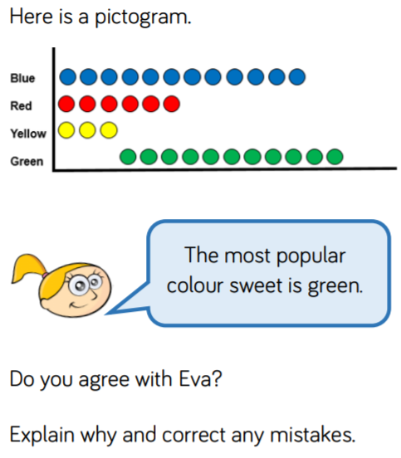

____________________________________________________________________________________________________________________________________________________________________________________________________________________________________________________________________________________________________________________________________________________________________________________________________________
2.
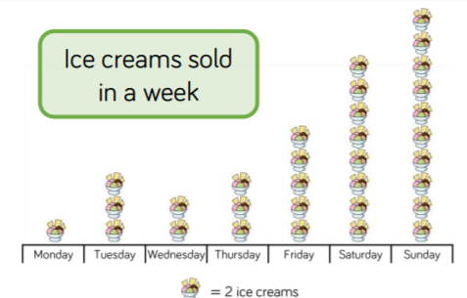
- Miss Jones says “there are more ice-creams sold at the weekend than during the rest of the week.” Is she correct? How do you know?
_______________________________________________________________________________________________________________________________________________________________________________________________________________
- Three ice creams were sold on Tuesday. True or False? Why?
__________________________________________________________________________________________________________________________________________

- If the staff needed to pick one day to have off during the week, which would be the best day and why?
_______________________________________________________________________________________________________________________________________________________________________________________________________________
3.
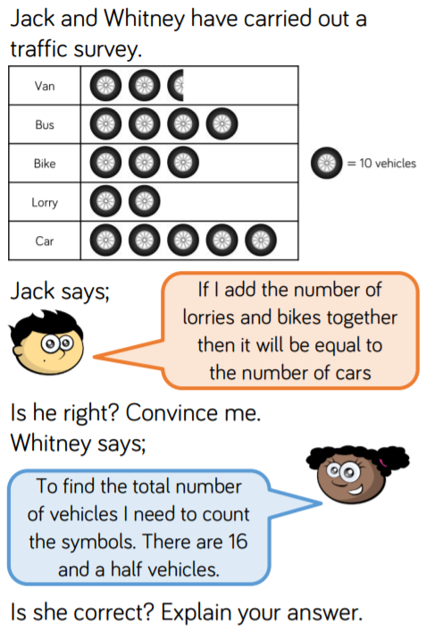
Top tip – always remember to look at the key on a pictogram!

__________________________________________________________________________________________________________________________________________

__________________________________________________________________________________________________________________________________________

