1.2.21
L/O: Can I identify 2D shapes from their properties?

Read the riddles below and work out which 2D shape is being described. Write the name of each shape next to the riddle. The pictures might help but can you remember what all of the shapes are called?

1 | 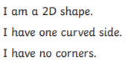 | What shape am I?
2 | 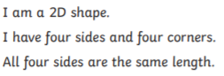 | What shape am I?
3 | 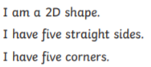 | What shape am I?
4 | 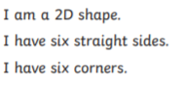 | What shape am I?
5 | 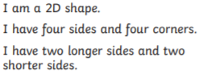 | What shape am I?
6 | 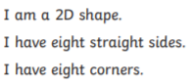 | What shape am I?

One of the shapes is missing its riddle. Can you write one for it?

