Monday 11th January 2021
L/O: Can I identify my personal qualities?

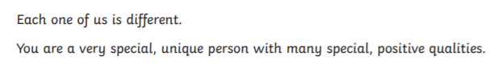

Complete this poster about your personal qualities. In the middle circle draw a picture of yourself and write your name.
