11.1.21
L/O: Can I interpret data from a bar chart?
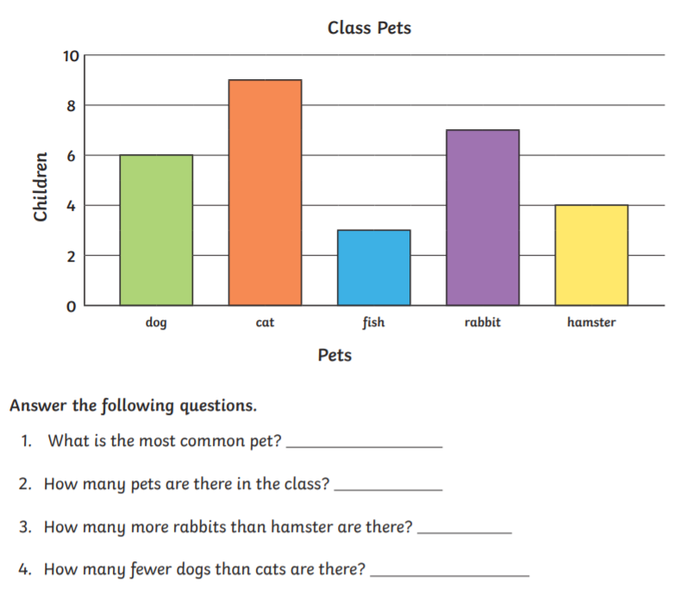
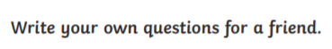
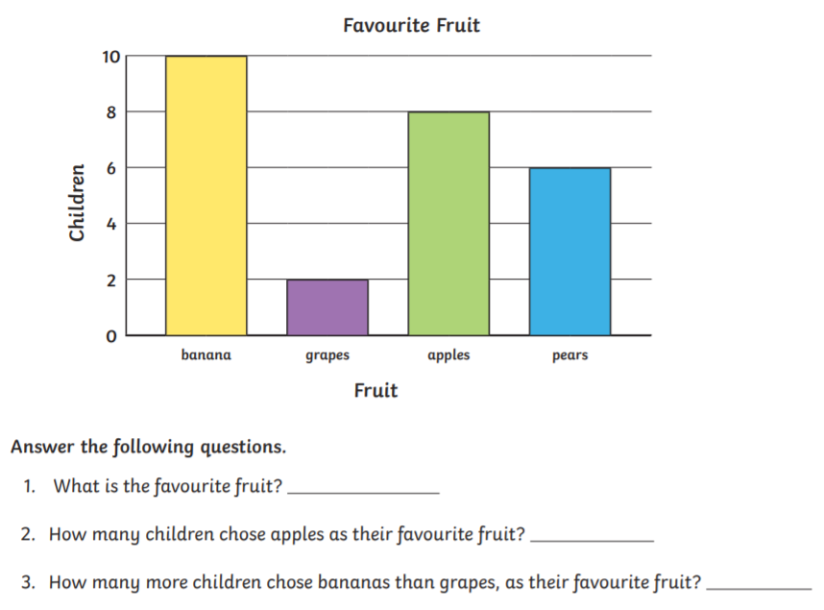
Extension:
_________________________________________________________________________

