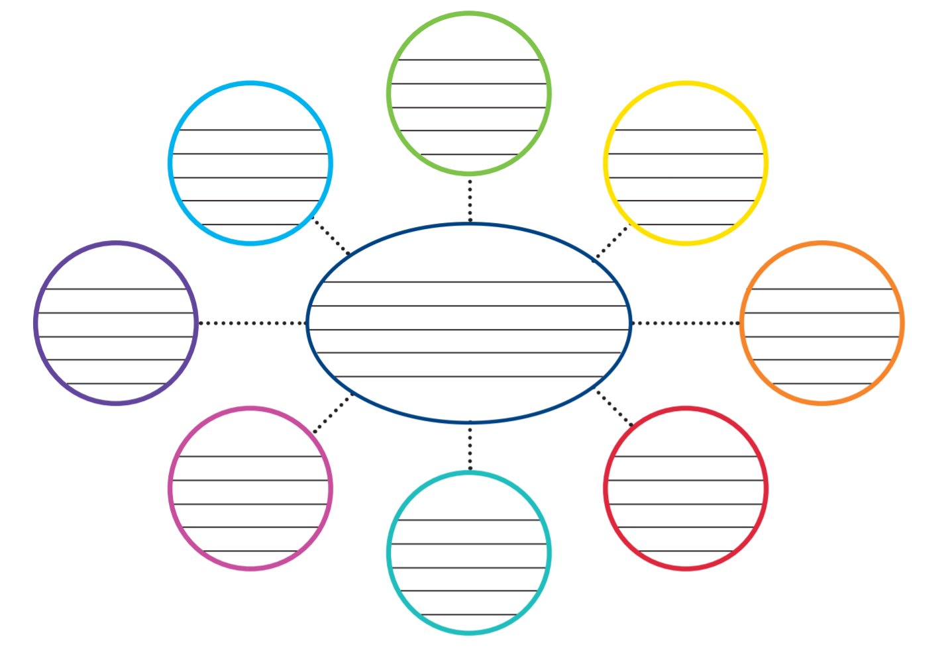
Monday 1st February 2021
L/O- Can I summarise statements that I know about Robin Hood?

