Thursday 4th January 2021
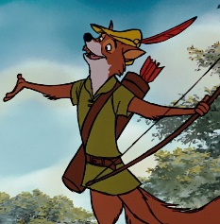
L/O- Can I use apostrophes for contractions?
I know that an apostrophe can show missing letters.
I can edit and improve my writing.
I understand how to use an apostrophe to join two word together to make one.
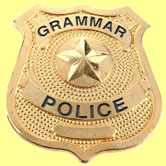
The Sheriff of Nottingham is collecting taxes from those who don’t use apostrophes correctly for contractions. Help Robin to edit the sentences below so that he doesn’t have to pay tax!
If you want an extra challenge, why not add some interesting adjectives or adverbs into your sentences too!

WAGOLL- Robin Hood would not steal money from the poor.
Young, boastful Robin Hood wouldn’t steal money from the poor.
- The Sheriff of Nottingham cannot capture Robin Hood.

____________________________________________________________________________________________________________________________________________________________________________________

- ‘You are the best archer in all of England!’’ said Friar Tuck.

____________________________________________________________________________________________________________________________________________________________________________________

- ‘I have been breathing through this reed,’ said Robin Hood.

____________________________________________________________________________________________________________________________________________________________________________________

EXT- Write your own sentences about the characters from Robin Hood. Include contractions.

