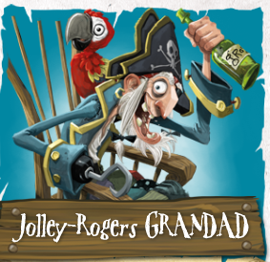
Thursday 14th January 2021
L/O: Can I edit and improve a piece of writing?
Yesterday I wrote a character description about Jolley-Rogers Grandad, but I have made a few mistakes. Your task today is to edit and improve my work. A few examples have been done for you.

Grandpa Rogers _________________________He________pirate
grandpa rogers is no ordinary man, he is a pirate! he lives on a piret
___________________________________________________
ship with his famelee he as two grandchildren called nugget and jim
___________________________________________________
lad grandpa wears a pirt hat and an ipach. Grandpa liks to drink grog
___________________________________________________
and helps the famelee with fings lik fixing the boat diging for tresur
___________________________________________________ and making the postman wak the plank. Do you fink he sounds lik a nis
_________
person.

