14.1.21
L/O: Can I use a Carroll Diagram?
A Carroll diagram is a way of sorting objects, numbers and shapes.
It looks like a table and has different criteria for you to sort with.

Can you sort these numbers onto the Carroll Diagram?

15 2 10 6 24 25 31 16 35 5

 | a multiple of 5 | not a multiple of 5
more than 20
20 or less

Can you sort these shapes onto the Carroll Diagram?
A B C D E F G

 | blue | not blue
triangle
not a triangle

Can you sort these numbers onto the Carroll Diagram?

23 60 71 12 49 100 36 55 84

 | more than 50 | 50 or less
odd
even

Can you sort these animals onto the Carroll Diagram?

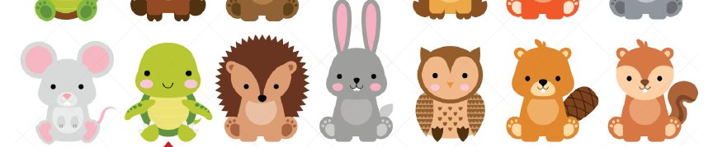
mouse tortoise hedgehog rabbit owl beaver squirrel

 | the colour brown | not the colour brown
has got wings
has not got wings

