

21.1.21 (reasoning/ problem solving)
L/O: Can I solve addition problems?
I know what a 2-digit number is.
I understand how to find all possibilities.
I can use x2 and x3 knowledge to solve problems.

Digit cards!
- Use the digit cards 1, 2, 3, and 4 to make two digit numbers.
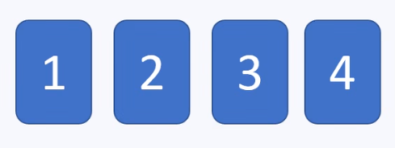
You will need to write your answers and working out on another piece of paper so that you have enough room!
You can make 12 different two-digit numbers, why are they?
- Which of the numbers can be divided exactly by 2?
- Which of the numbers can be divided exactly by 3?

Convince me
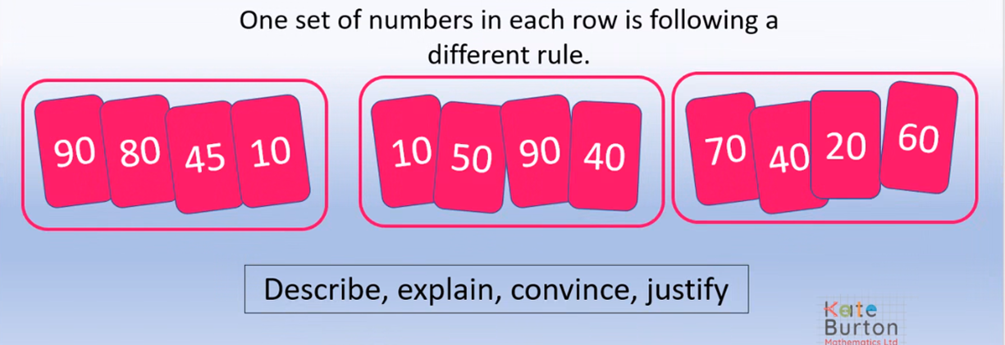

Explain which set of numbers is different and why:
____________________________________________________________________________________________________________________________________________________________________________________________________________________________________________________________________________

