


21.1.21 (reasoning/problem solving)
L/O: Can I solve addition problems?
I know addition number facts to 10.
I understand what total means.
I can add three one-digit numbers mentally.

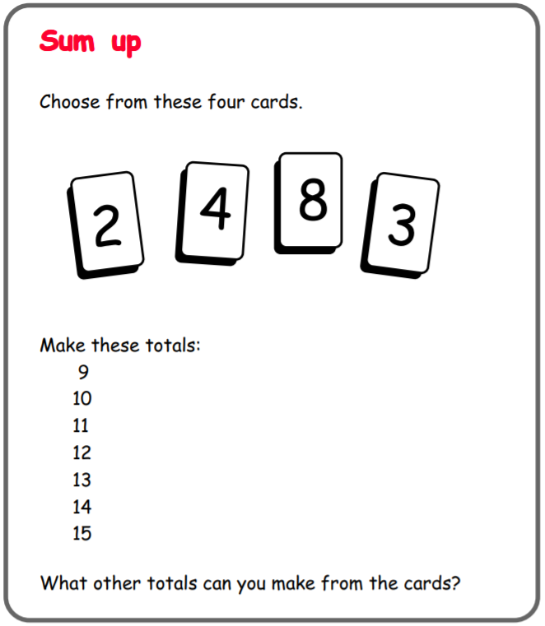
You will need to write your answers and working out on another piece of paper so that you have enough room!

Convince me
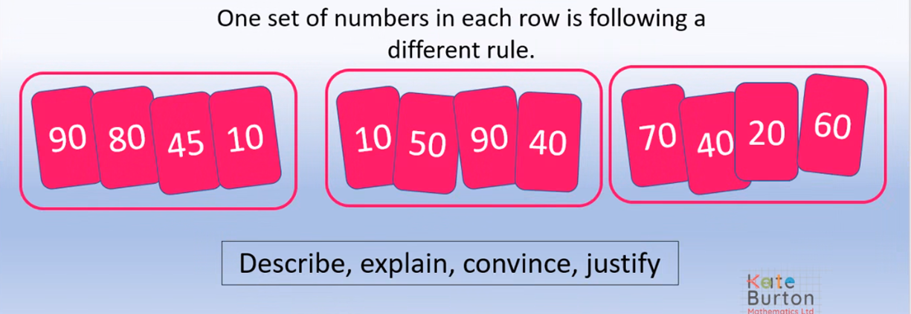

Explain which set of numbers is different and why:
____________________________________________________________________________________________________________________________________________________________________________________________________________________________________________________________________________________

