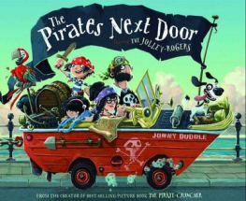
Thursday 7th January 2021
L/O: Can I use adjectives and adverbs to describe?
Today we will be describing the main characters from the story ‘The Pirates Next Door’.

Add adverbs and adjectives in the correct places. Adverbs are used to describe verbs so make sure you only use them in the spaces just before verbs (doing words).

We're the Jolly-Rogers! We will be anchoring next door.
There's Mum who is __________________ digging up the grass. She has ______________________ hair and a ________________ hooped earring in her ears.
Next is Dad. He likes to _______________________ bury treasure to keep it safe. He has a ______________________ beard and always wears a __________________________.
Now write your own sentences about Grandpa pirate and little
sister Nugget. Don’t forget adverbs and adjectives to describe!

______________________________________________________________________________________________________________________
_________________________________________________________________________________________________________________________________________________________________________________

