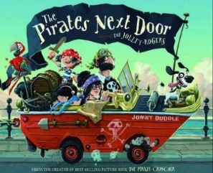
Tuesday 12th January 2021
L/O: Can I create a word bank?
Tomorrow we will be writing a character description for Jim Lad. Today we want you to think of any adjectives or noun phrases that you could use in your writing tomorrow. There area few ideas in each column to get you started.
Appearance  filthy  jet black hair  mucky  tatty shorts  ________________________________  ________________________________  ________________________________  ________________________________  ________________________________  ________________________________  ________________________________ | Personality  adventurous  fearless  friendly  ________________________________  ________________________________  ________________________________ | What do we know about him?  He is a pirate called Jim-Lad.  He has a little sister called Nugget.  ________________________________  ________________________________  ________________________________  ________________________________
 | What does he do?  He sails the seven seas.  He buries treasure.  ________________________________  ________________________________  ________________________________  ________________________________ | 