12.1.21
L/O: Can I create a bar chart?
Which is the most popular colour in a Smarties tube?
Use this picture to complete the tally chart below:
 | Tally | Frequency
red
orange
blue
green
yellow
brown
purple
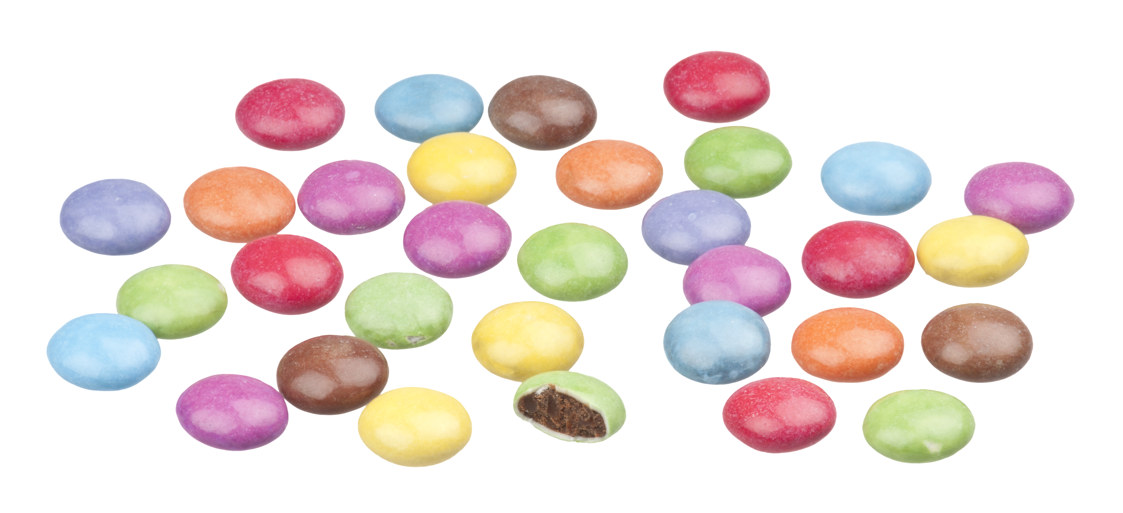

Now transfer this data onto a bar chart (you can either draw this by hand or use Purple Mash)

