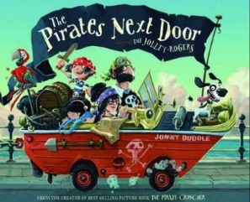
Wednesday 13th January 2021
L/O: Can I use paragraphs to organise my writing?
Use the word bank that you made yesterday to write a character description for Jim Lad. Each of the four sections will make up a paragraph.

Appearance (paragraph 1)
______________________________________________________________________________________________________________________________________________________
______________________________________________________________________________________________________________________________________________________

Personality (paragraph 2)
______________________________________________________________________________________________________________________________________________________
______________________________________________________________________________________________________________________________________________________

What do we know about him (paragraph 3)
______________________________________________________________________________________________________________________________________________________
______________________________________________________________________________________________________________________________________________________
______________________________________________________________________________________________________________________________________________________

What does he do? (paragraph 4)
______________________________________________________________________________________________________________________________________________________
______________________________________________________________________________________________________________________________________________________
______________________________________________________________________________________________________________________________________________________

