6.1.21
L/O: Can I complete a tally chart?

Can you complete the tally and frequency columns of this tally chart?

Vehicle Colour | Tally | Frequency
White
Green
Silver |  | 7
Blue |  | 3
Red

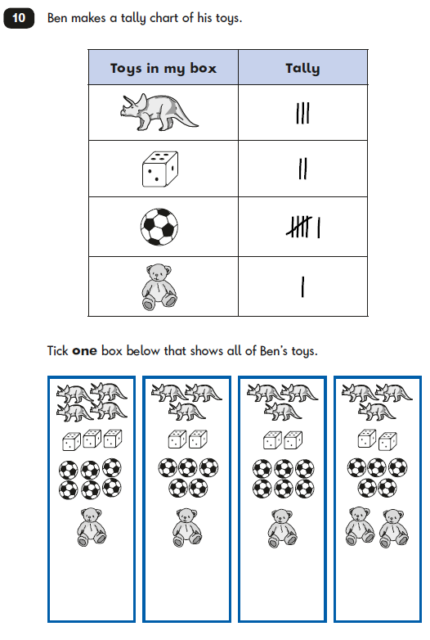
Convince me

