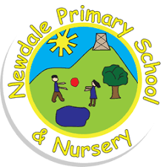
Year 5 Homework
Times Tables Test – Every Wednesday
Spelling Test- Every Friday

Spelling | Spelling Rule: The ‘ee’ sound spelt ‘ei’  Extension: Use a dictionary to define unfamiliar words in the list.
receive
deceive
ceiling
receipt
conceit
conceive
seize
protein
caffeine
either
Reading  Daily (x5)  Please write comments on your e-diary | 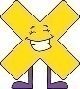  Times Tables  Three Times a Week  There is a tournament on! | Homework  Spend time with your family doing something you all enjoy!

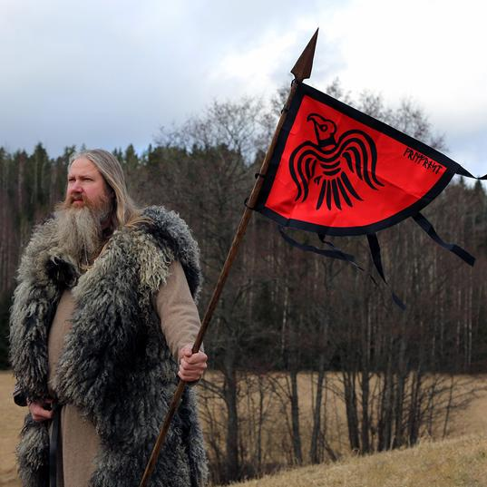
Viking Banners
This week, we would like you to get crafty and create your very own battle standard! A battle standard was a flag or banner which would inspire your troops on the battlefield. Use viking symbols and runes to decorate your banner. You may want to include powerful symbols from mythology, such as Mjollnir. If you search “viking banner,” This should give you a few great ideas.

Viking Banners
This week, we would like you to get crafty and create your very own battle standard! A battle standard was a flag or banner which would inspire your troops on the battlefield. Use viking symbols and runes to decorate your banner. You may want to include powerful symbols from mythology, such as Mjollnir. If you search “viking banner,” This should give you a few great ideas.

Viking Banners
This week, we would like you to get crafty and create your very own battle standard! A battle standard was a flag or banner which would inspire your troops on the battlefield. Use viking symbols and runes to decorate your banner. You may want to include powerful symbols from mythology, such as Mjollnir. If you search “viking banner,” This should give you a few great ideas.

