FOOD DIARY  Week 1 | Monday | Tuesday | Wednesday | Thursday | Friday | Saturday | Sunday
Breakfast

Lunch

Dinner

Snacks

Drinks

Glasses of water aim for 6-8 per day
(tally)

ACTIVE DIARY - Week 1 |  | Activity |  |  | Duration |  |  | Post active feeling n- Rate 1 – 5  1 = not great, 2=ok, 3= good, 4=really good, 5= AMAZING
Monday

Tuesday

Wednesday

Thursday

Friday

Saturday

Sunday

FOOD DIARY  Week 2 | Monday |  | Tuesday | Wednesday |  | Thursday | Friday |  | Saturday | Sunday
Breakfast

Lunch

Dinner

Snacks

Drinks

Glasses of water aim for 6-8 per day
(tally)

ACTIVE DIARY - Week 2 | Activity | Duration | Post active feeling n- Rate 1 – 5  1 = not great, 2=ok, 3= good, 4=really good, 5= AMAZING
Monday

Tuesday

Wednesday

Thursday

Friday

Saturday

Sunday

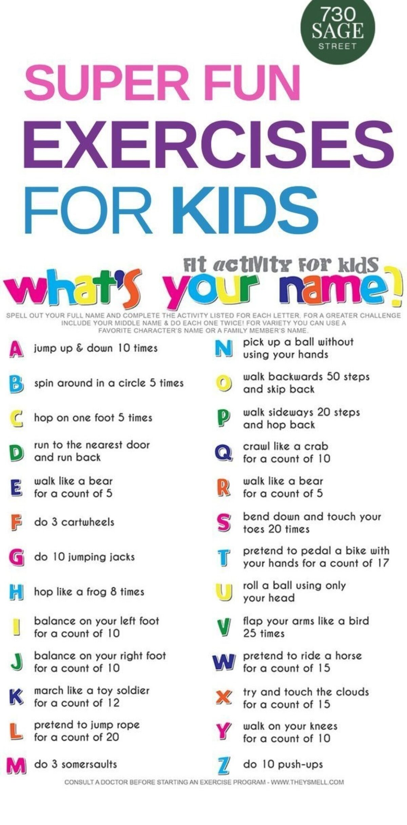
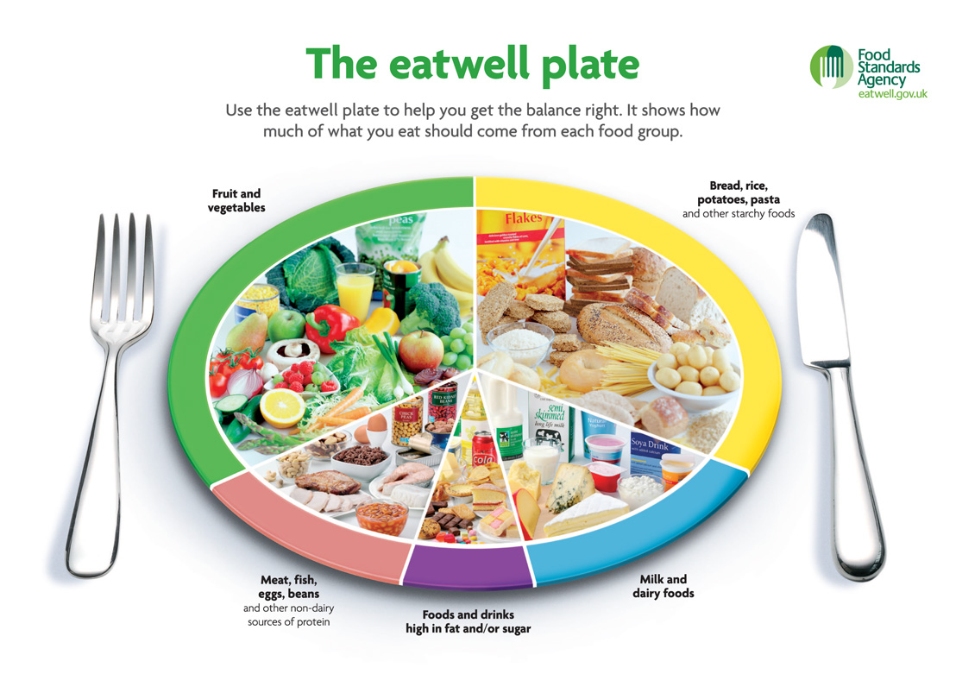
Some active activities for you to try!
- Go for a walk, jog or a run (take your dog with you if you have one)
- Go on a bike ride
- Go on your scooter
- Play a ball game
- Play tennis, bat and ball, catch and throwing games
- Skipping
- Do 20minutes of dance (get the disco tunes on and boogie)
- Complete a fitness workout (get your grown ups involved too)
- Any other activity that gets your heart rate pumping!

