15.03.21 Year 1 spellings Mrs Goodwin’s group (Phase 3 sounds-ai,ee)
Look, cover, write, check. | Practise 1 | Practise 2 | Practise 3 | Practise 4 | Practise 5
rain
wait
tail
tree
queen
sleep

15.03.21 Year 1 spellings Mrs Goodwin’s group (Phase 3 sounds- ai,ee)
Look, cover, write, check. | Practise 1 | Practise 2 | Practise 3 | Practise 4 | Practise 5
rain
wait
tail
tree
queen
sleep

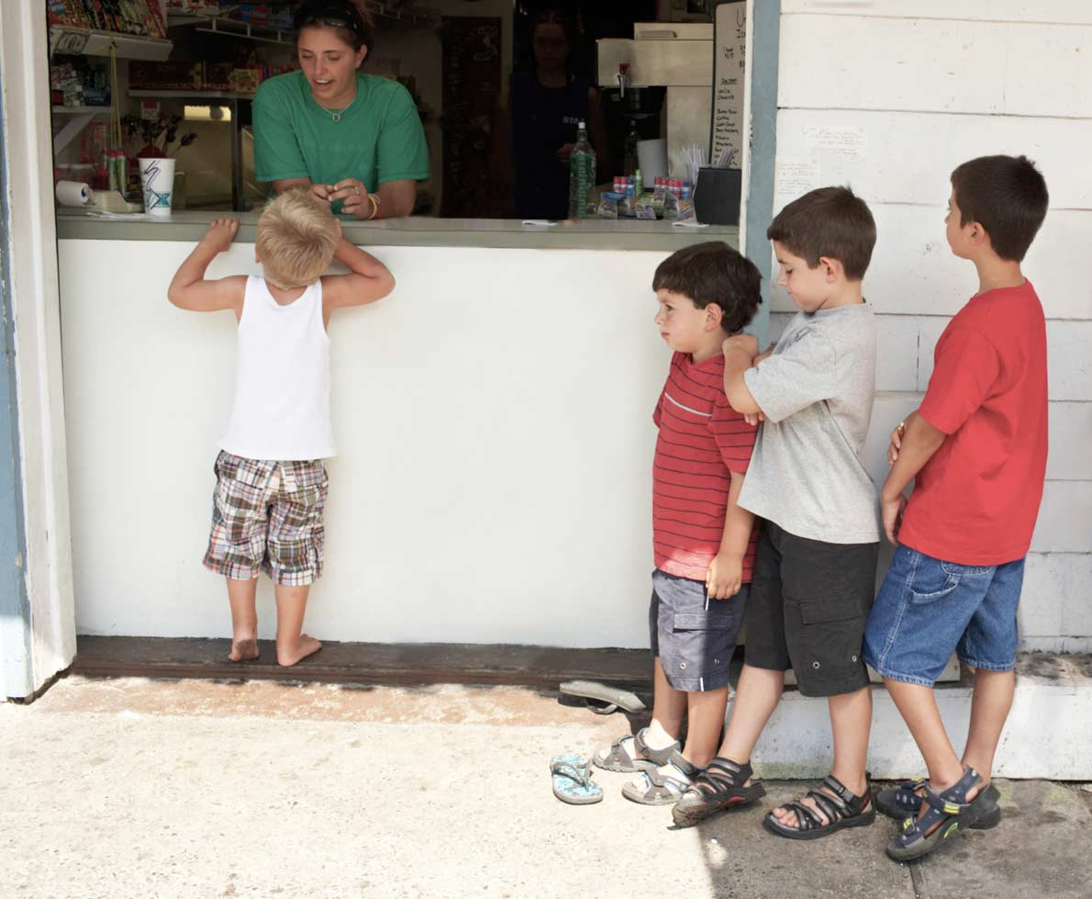

rain
wait
tail
paid
hail
nail
feet
tree
queen
sleep
green
seed

