26/04/21 Year 1 spellings Mrs Lee’s group (Phase 3 sounds-oo,er)
Look, cover, write, check. | Practise 1 | Practise 2 | Practise 3 | Practise 4 | Practise 5
kerb
herd
never
better
book
look
took
shook

26/04/21 Year 1 spellings Mrs Lee’s group (Phase 3 sounds-oo,er)
Look, cover, write, check. | Practise 1 | Practise 2 | Practise 3 | Practise 4 | Practise 5
kerb
herd
never
better
book
look
took
shook

kerb
herd
never
better
letter
finger
book
look
took
shook
foot
cook

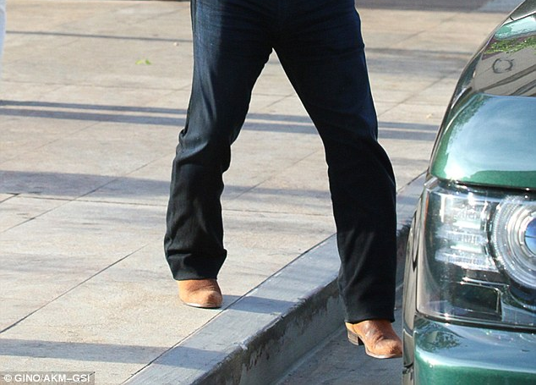
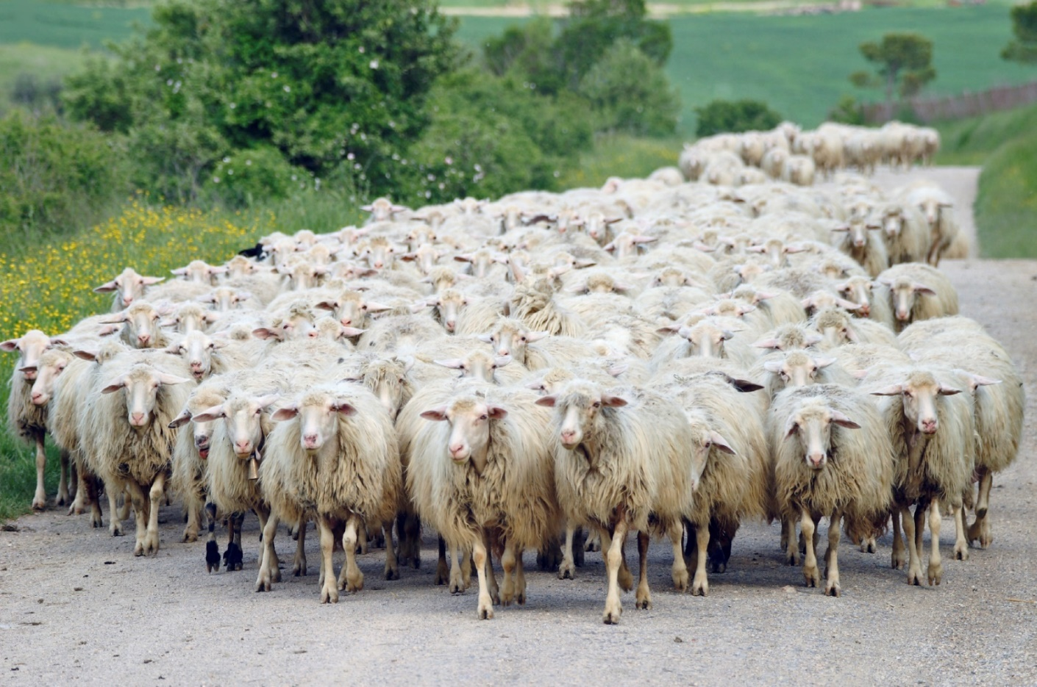

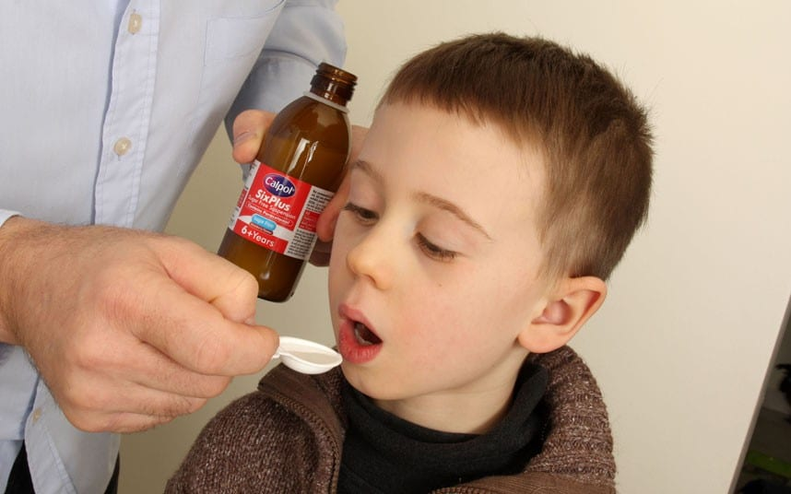
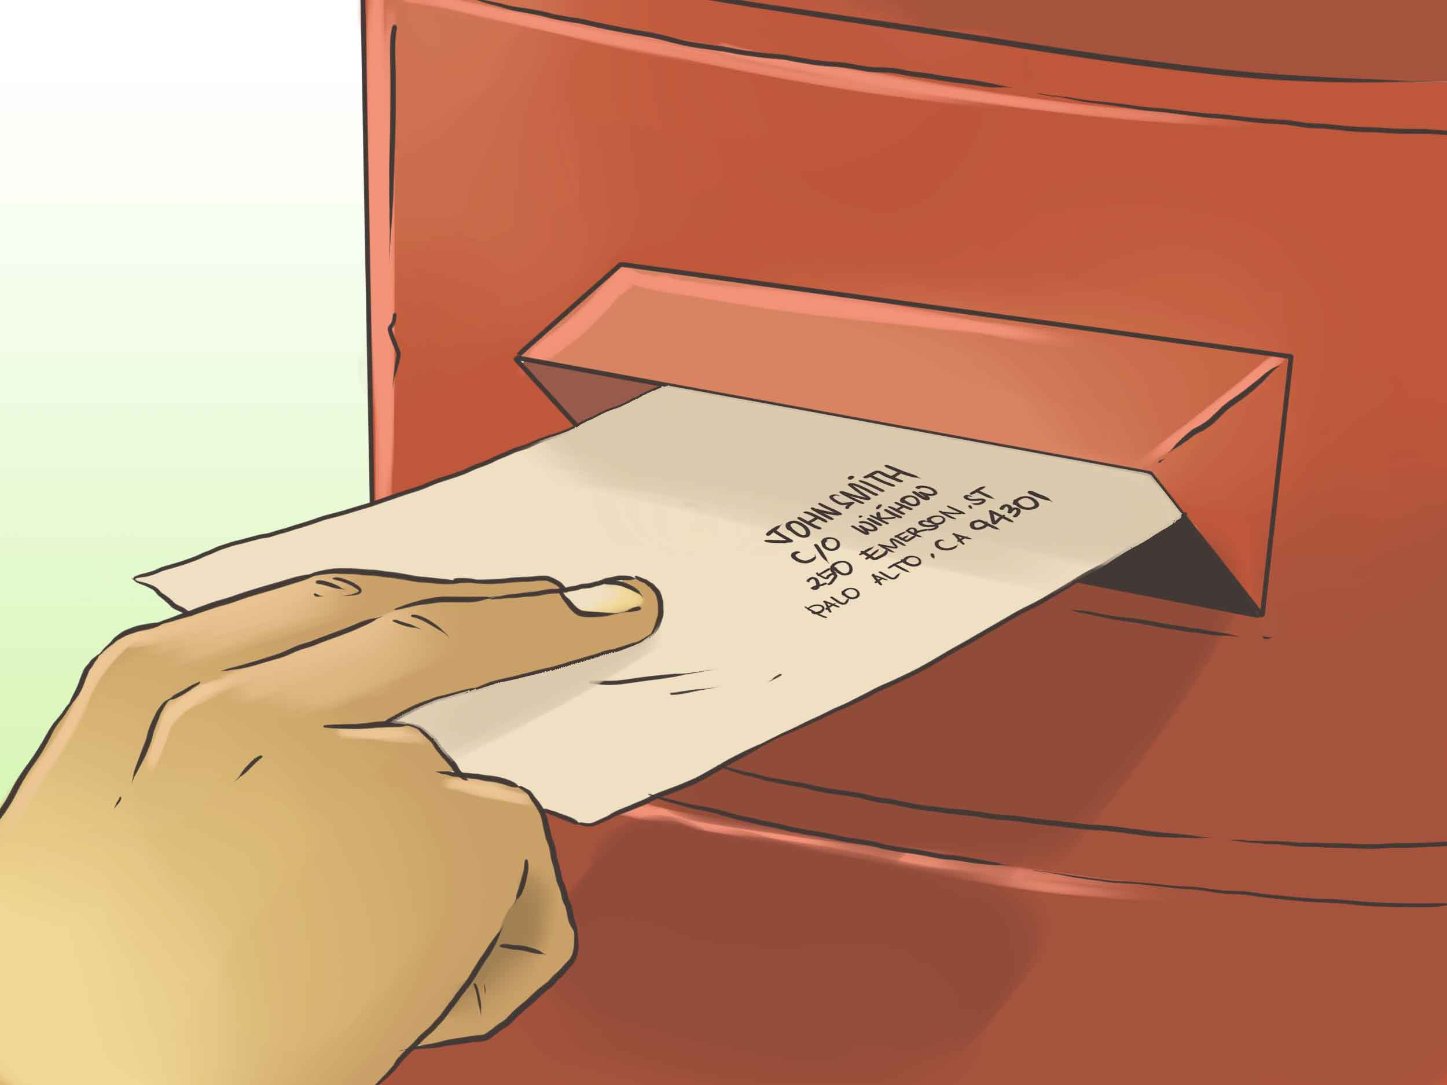



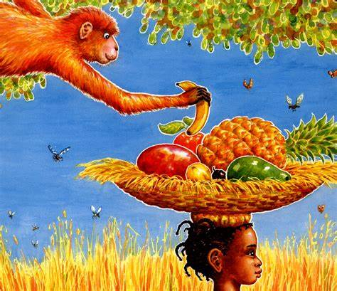

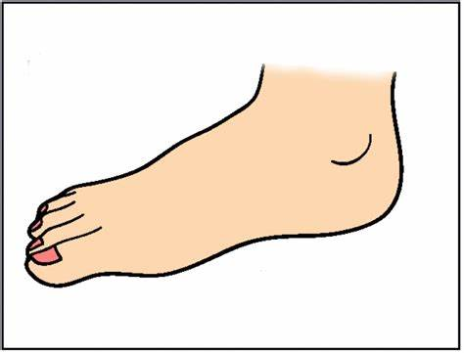


gerb
cherd
merl
tersh
ferp
zerch
shoob
troog
thoo
cloop
noov
proom

Intervention A
Focus sound ‘ow’

Hold a sentence:
He is a brown cow.
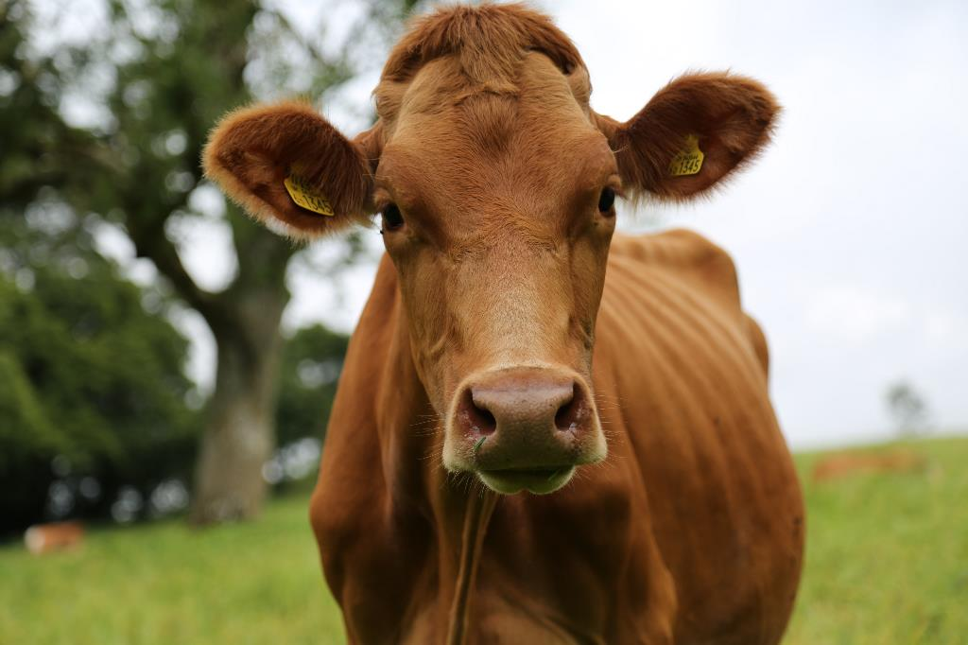
Edit a sentence: (5 errors)
the al is Big and. bran
The owl is big and brown.
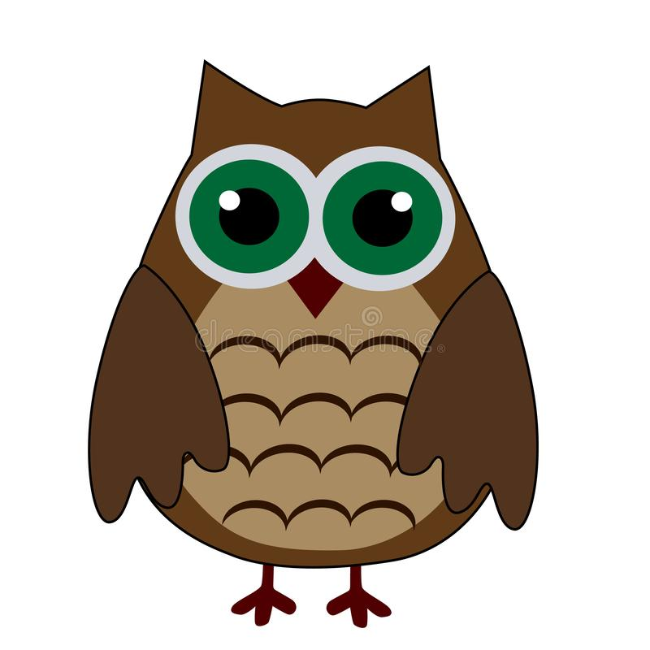
Intervention B
Focus sound ‘er’

Hold a sentence:
It is a herd of sheep
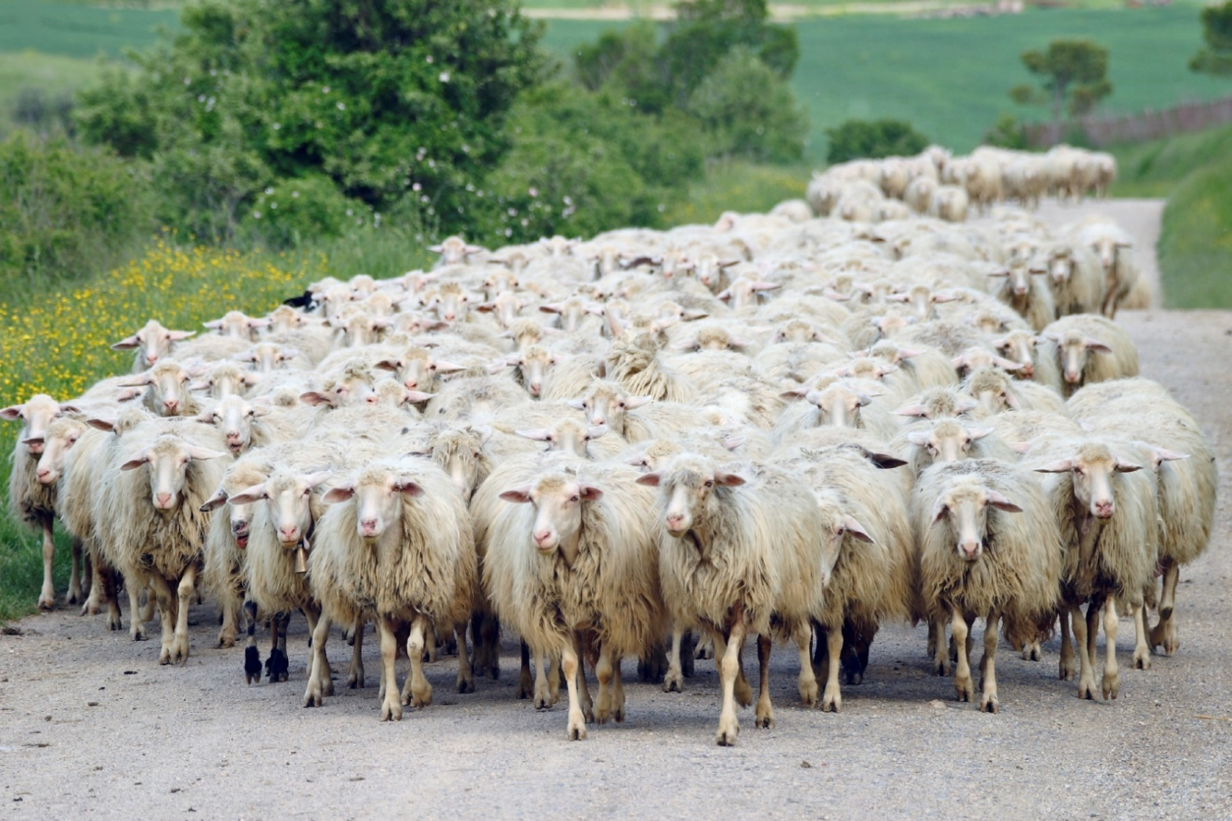
Edit a sentence: (6 errors)
he iz filing betta nuw
He is feeling better now.

