26.04.21 Year 1 spellings Mrs Goodwin’s group
 | Practise 1 | Practise 2 | Practise 3 | Practise 4 | Practise 5
surf
turn
burn
turnip
cow
owl
town
brown
This week we are learning the ur and ow sounds.

26.04.21 Year 1 spellings Mrs Goodwins’s group
 | Practise 1 | Practise 2 | Practise 3 | Practise 4 | Practise 5
surf
turn
burn
turnip
cow
owl
town
brown
This week we are learning the ur and ow sounds.

surf
turn
burn
turnip
cow
owl
town
brown

clurt
brurg
trurb
shurp
thurn

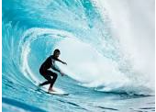

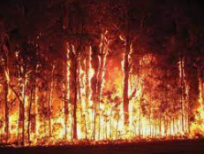
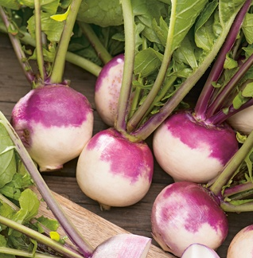
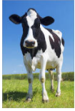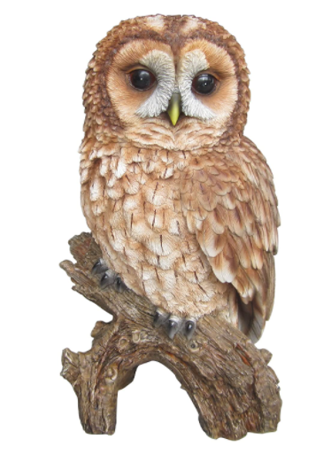

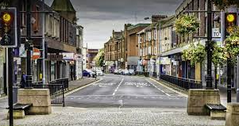

coat
foal
toad
boat
goat
toast

quowb
flowp
crowm
browf
powzz
howch

