30/04/21 Year 1 spellings Mrs Lee’s group (Phase 3 sounds-oi, ur)
Look, cover, write, check. | Practise 1 | Practise 2 | Practise 3 | Practise 4 | Practise 5
soil
coin
join
foil
turn
burn
burp
hurt

30/04/21 Year 1 spellings Mrs Lee’s group (Phase 3 sounds-oi, ur)
Look, cover, write, check. | Practise 1 | Practise 2 | Practise 3 | Practise 4 | Practise 5
soil
coin
join
foil
turn
burn
burp
hurt

soil
join
coin
foil
spoil
point
turn
burn
burp
hurt
slurp
curl

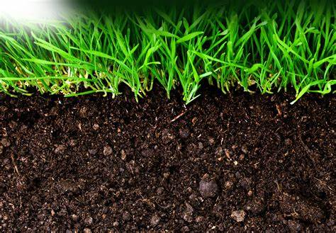
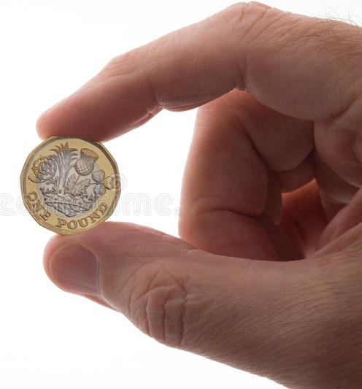

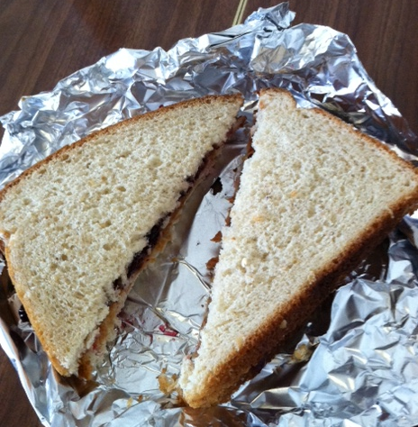



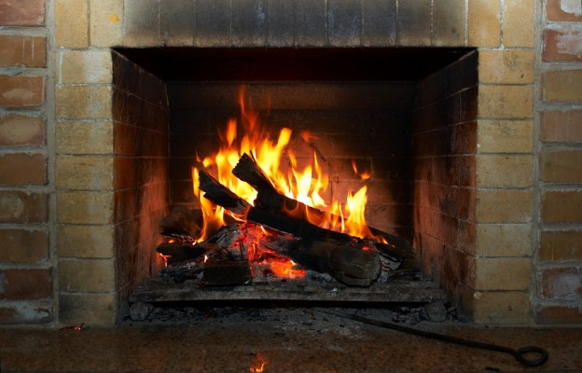
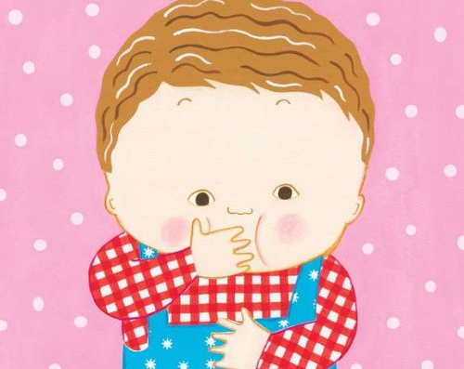




groib
choid
moil
toish
froip
zoich
shurb
trurg
thurp
clurd
nurch
crurm

