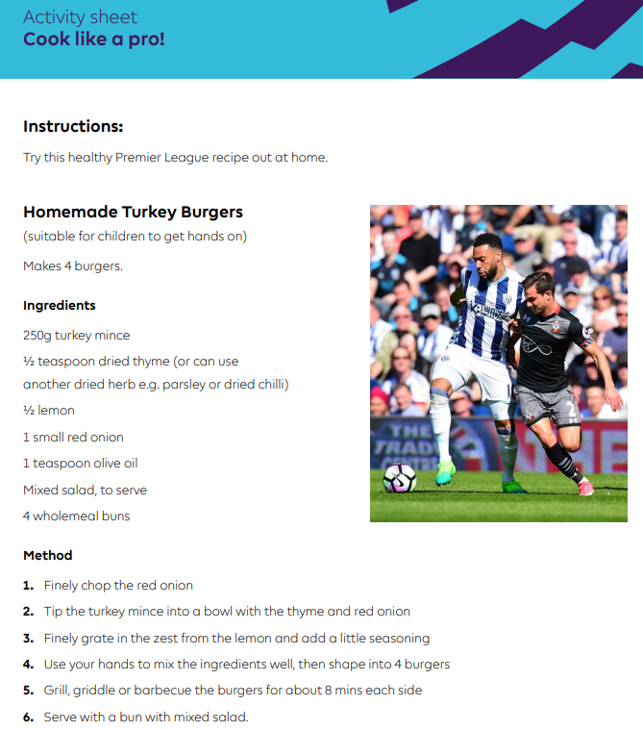

Next week is ‘Healthy Lifestyles Week’ in school. Can you help you parents or carers to cook a healthy meal? Upload a picture to the blog or draw out your meal into your homework book.

Next week is ‘Healthy Lifestyles Week’ in school. Can you help you parents or carers to cook a healthy meal? Upload a picture to the blog or draw out your meal into your homework book.