Moving to Year R

We are really looking forward to seeing you in September.
Here is some Year R information to help you to settle into your new class.

Year R Class Teachers



Miss Hailey
Base 6

Mrs Sturrock
Base 5
Thursday and Friday
Mrs Evans
Base 5-
Monday , Tuesday and Wednesday

Other staff who work in Year R
Mrs Stevens
Teaching Assistant


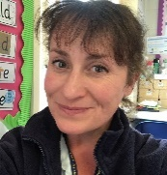
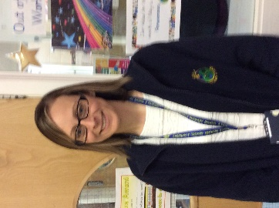

Mrs Cleobury
Teaching Assistant
Mrs Bissell
Teaching Assistant
Miss Marshall
Teaching Assistant

Year group entrance and lining up
On the other side of this sheet you will see a map which will show you the entrance to use for your new class.
What to bring on your first day
- Water bottle
- Packed lunch (if required: Starting from Friday 9th September)

P.E. will be a Wednesday ( Outdoor PE) and Thursday (Indoor PE). Starting Week 2.
Forest School will be a Monday afternoon. Starting Week 3
Homework
It will really help your child to make excellent progress if you read nightly with them. We will change books frequently, in line with how often your child is reading. Children will be encouraged to change their books by themselves to develop their independence. In addition to this we also set Parents as Partners tasks. These will be a variety of fun and practical tasks that relate to the learning going on in school at that time. It provides the opportunity for your child to extend their knowledge and skills as well as keeping you up to date of what they have been or will be doing soon.

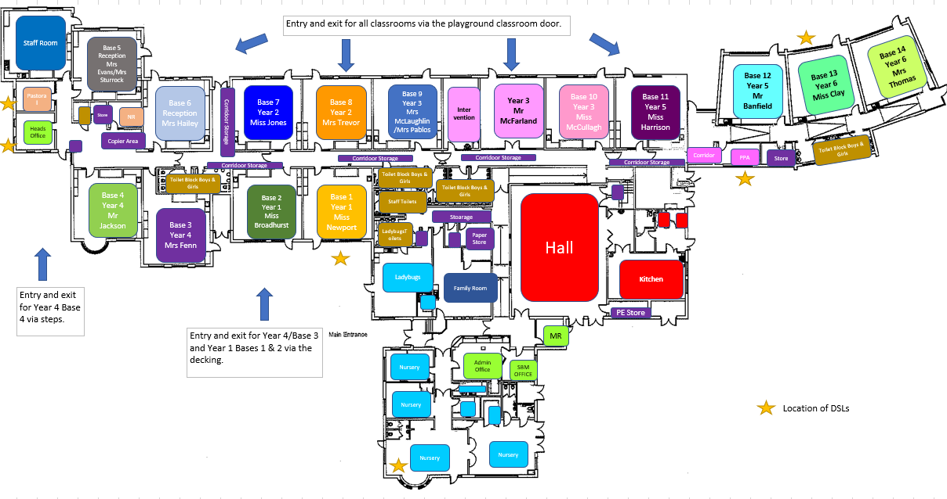
Mrs Evans/Mrs Sturrock’s Classroom
Miss Hailey’s Classroom.

