Constellations
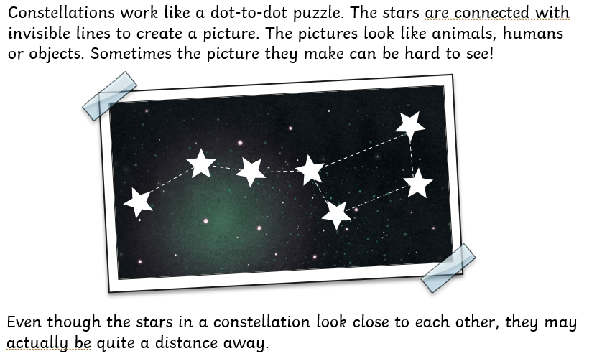
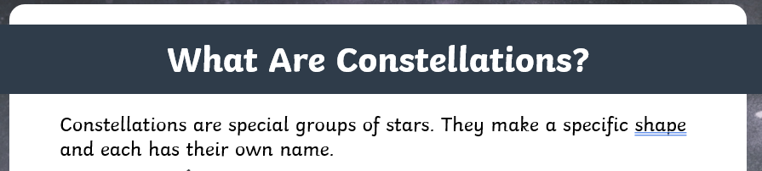

Research the constellation of your birth month. Include:
- Its name
- What it looks like in the night sky
- Interesting facts.
EXT: Create your own constellation. What would it look like and why?

