Shape hunt in and outside your home!
Draw or write the 2D/3D shapes you find around your home.
Fill in this table or make your own.
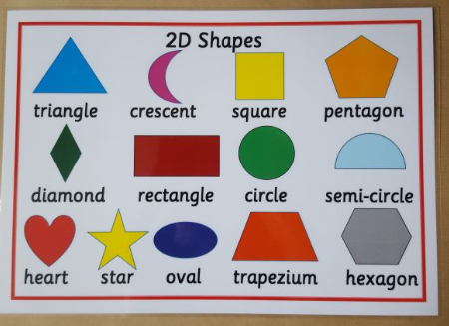  2D shapes | 3D shapes  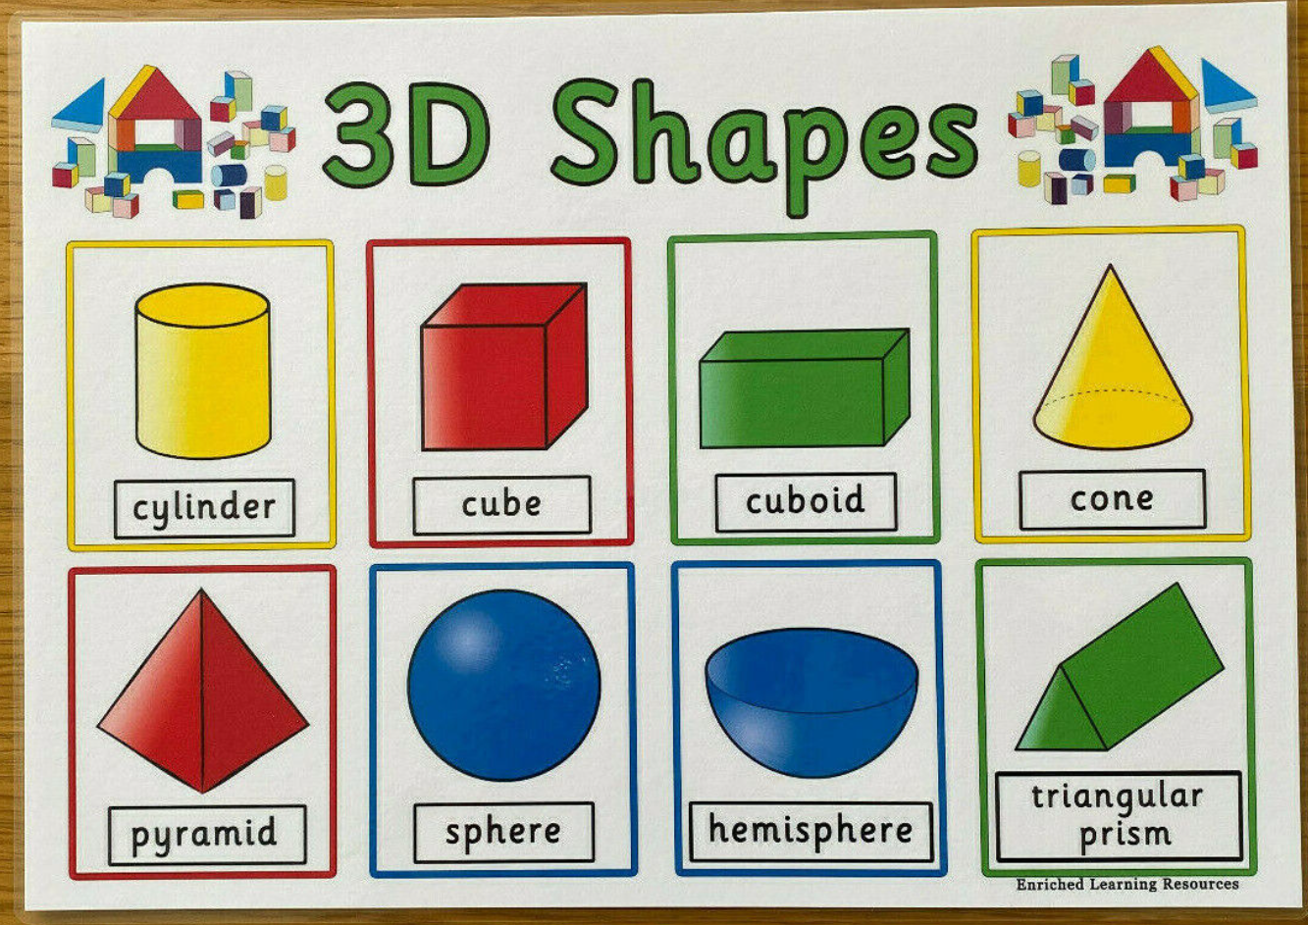

Challenge – Can you make 3D shapes in the snow?

