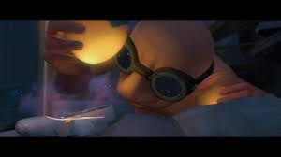

Draw The Dream Giver and label him using expanded noun phrases
Think about – head, eyes, goggles, wings, body,
how he holds dreams
WAGOLL – his vast, luminous wings

