Story in a Box Competition Ideas
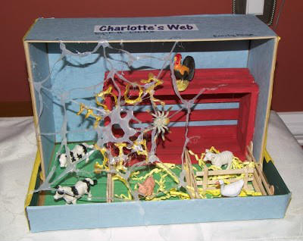
Charlotte’s Webb

3 Little Pigs
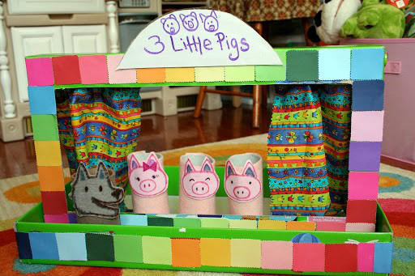

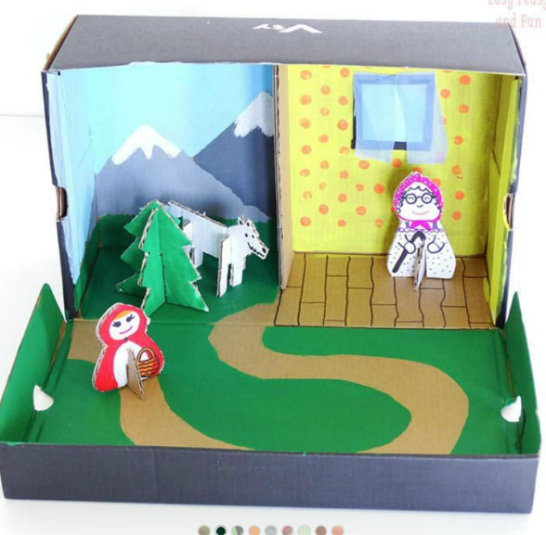
Little Red Riding Hood

If your child wishes to take part in the competition, please make sure they fill this form in and return it with their box by Monday 3rd March. Forms can be collected from your child’s class teacher.
