Music
Recorders
PE
- Tennis (outdoor)
- Dance (indoor)

Life Learning
Water Safety
Keeping and Staying Healthy
First Aid
RE
For Christians, when Jesus left; what was the impact of Pentecost?
Science
- Animals including humans:
- Information texts on Digestion (Literacy link)
- Describe the simple functions of the basic parts of the digestive system in humans.
- Identify the different types of teeth in humans and their simple functions.
- Construct and interpret a variety of food chains, identifying producers, predators and prey.

History
How far did the Anglo-Saxon invasion change Britain?
- Why did the Saxons come to Britian?
- How did they rule Britian?
- What was life like in Anglo-Saxon Britain?

DT
-Anglo-Saxon purses (joining techniques: whip and blanket stitch)

Year 4 Curriculum
Summer One 2025

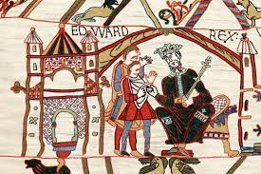
Computing
Creating Media –
Editing digital images
MFL
Les vêtements (Clothes)

Maths
Number and Place Value: Roman numerals
Addition and Subtraction (solving problems)
Multiplication and division (solving problems including correspondence)
Fractions: decimal and fractions in the context of measurements
Measurement
Geometry: symmetry
All four operations: written methods
Number and Place Value: negative and positive numbers
Geometry: properties of shape
Statistics: represent and interpret data

Literacy and Guided Reading
- Myths and Legends incl. Beowulf, Theseus and the Minotaur, The Little Mermaid (fiction, descriptive writing)
- Kenning poetry
- Anglo-Saxon non-fiction information text
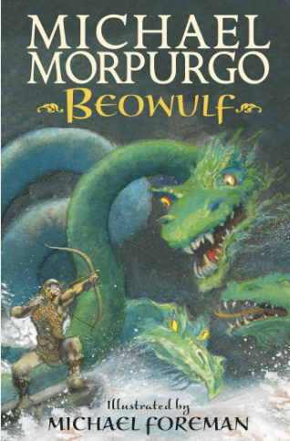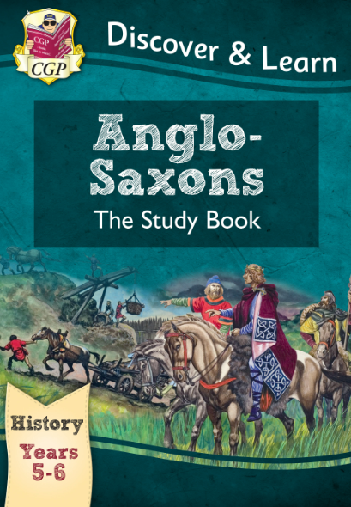

Websites we will be accessing this half term:
https://www.timestables.co.uk/
https://ttrockstars.com/
https://www.topmarks.co.uk/maths-games/hit-the-button
https://www.bbc.co.uk/bitesize/primary
https://kids.kiddle.co/Anglo-Saxons

Trips/In school experiences
- Anglo-Saxon Workshop (in school)

