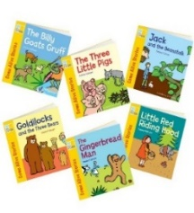

Understanding the World
Growing – how plants grow and how humans grow and change. Toys from the past – we will be having a show and tell in the last week of half term. Can you compare toys you play with now to a parent’s or Grandparent’s toy? Please send in pictures on Evidence Me. More details to follow.
Computing- Colour catchers.
Understanding of seasons - How is the weather changing?
RE: Which places are special and why with a focus on Christianity and Islam.
Forest school – Thursday.

Physical Development
Outdoor Area: bikes, scooters, balancing beams, stepping stones, jungle gym, PE equipment.
Inside: fine motor activities such as tweezers, writing in sand, beads, peg boards, lacing cards.
PE lessons (Thursday and Friday):
Indoor PE: Gymnastics
Outdoor PE: Athletics
Literacy & Communication
and Language
Talk partners and speaking and listening circle time activities, drama/role play, acting out stories.
Shared Texts
Handa’s Surprise
Sam Plants a Sunflower
Percy the Park Keeper
Errol’s Garden
The Extraordinary Gardener
Writing
Children will learn to write a simple sentence with a capital letter, finger space and full stop.
Reading and Phonics
During our Read Write Inc (RWI) phonics and reading sessions, children will learn new letter sounds and how to blend these together to read a word. We will also be sharing a range of stories with the children and discussing what we have read and the features of fiction and non-fiction texts.



Year R Curriculum 2025-2026
Spring Term
GROWING


Expressive Arts and Design
Collage – colour catchers and observational drawings. Artist – Mondrian.
Role Play: Garden Centre
Music: Charanga (Our World), Singing Traditional Rhymes, Counting Songs
Story Telling and Acting

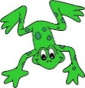


Maths
Doubles (1+1, 2+2, 3+3, 4+4, 5+5)

Composition of 8

Quick recall of number bonds to 5

Corresponding subtraction facts for number bonds to 5

Personal, Social, Emotional Development
1decision: What is fair? Telling an adult about an accident. What to do if someone tells a lie about me/telling the truth. Choosing who to play with.
British Values
Online safety



