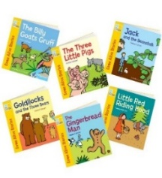
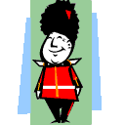
Understanding the World
Forest School: Understanding the Changing of seasons. Welcoming Summer. Exploring things that grow.
What lives under the Sea?
How can we help save our Planet and Animals? Why is it important to recycle?
Careers day- Learning about different people’s occupations and people that help us.
Keeping our bodies and minds healthy – Healthy lifestyles week and Sports day.
Transition to Year 1. We will prepare your child for the move up into their next class at the end of the school year.

Physical Development
Outdoor Area: bikes, scooters, balancing beams, stepping stones, jungle gym, PE equipment.
Inside: fine motor activities such as tweezers, writing in sand, beads, peg boards, lacing cards.
PE lessons (Monday and Thursday):
Indoor PE: Gymnastics
Outdoor PE: Athletics
Literacy & Communication
and Language
Literacy & Communication
and Language
Talk partners and speaking and listening circle time activities, drama/role play, acting out stories.
Shared Texts
The Snail and The Whale
Somebody Swallows Stanley
Tiddler
What The Ladybird Heard At The Seaside
Writing
Children will continue to learn to write a sentence with a capital letter, finger space and full stop. We will begin to extend our sentences using the conjunction ‘and’.
Reading and Phonics
During our Read Write Inc (RWI) phonics and reading sessions, children will learn new letter sounds and how to blend these together to read a word. We will be applying our phonetic knowledge to read story books matched to our sound knowledge with more fluency.

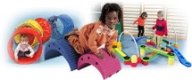
Year R Curriculum 2024-2025
Summer Term 2
Under the Sea

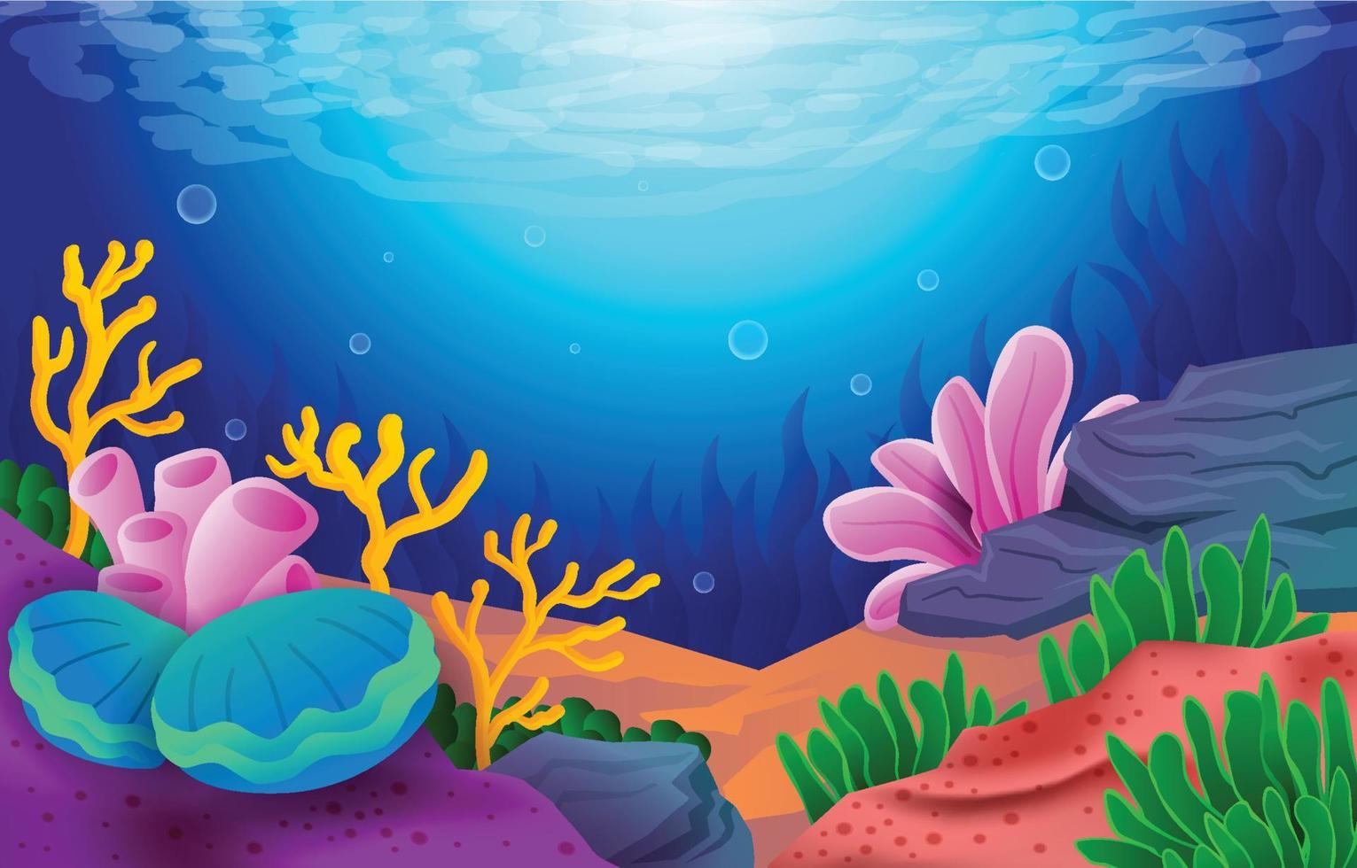

Expressive Arts and Design
- Under the Sea and themed Crafts/Art
- Learning about the artist Mondrian and making Mondrian inspired flags.
- Role play area: Beach Hut, Souvenir Shop
- Using various construction materials to build and balance.
- Art to celebrate Father’s Day.
- Art Day!
- Charanga scheme for music.


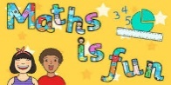
Maths
•Subitise to 5 confidently.

•Explore the composition of numbers to 9.

•Automatically recall number bonds for numbers 0-5 and 0–10.

•Exploring non-standard measure in terms of weight and capacity.

Personal, Social, Emotional Development
Building confidence / Developing independence with resources / Initiating play / Valuing praise/describe self in positive terms.
Life Learning: Keeping our bodies and mind healthy.
Transition into Year 1, a positive attitude to learning and learning about changes in our lives.
Career’s week, Hopes and aspirations for the future.
Healthy Lifestyles Week.

