
Monday 6th July 2026
Dear Parents and Carers,
We are pleased to inform you that from September 2026, we will be introducing Class Dojo as part of our classroom practice for children in Reception through to Year 6.
What is Class Dojo?
Class Dojo is a secure online platform designed to support positive behaviour, communication, and the celebration of pupils’ achievements. It allows teachers to award points in real time and helps parents stay informed about their child’s effort in school.
How will it work in our class?
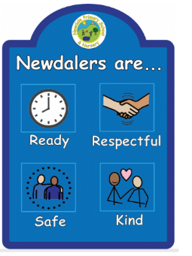
Children will be able to earn Dojo points for consistently following our school behaviour expectations:
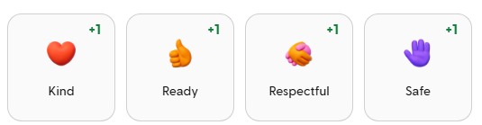
- Ready
- Respectful
- Safe
- Kind
These points will be used to recognise and celebrate positive choices made throughout the school day.
Rewards and incentives
At the end of each half term, children will have the opportunity to exchange their Dojo points for prizes from their ‘Class Dojo Shop’. This will help motivate and reward their continued positive behaviour and effort.
House system
Our existing house system will continue and will now be linked to Class Dojo. This means we will still enjoy our half-termly house celebrations, which have been such a success. As a result, we will no longer be using separate house points- Dojo points will go towards this instead.
For parents and carers
Parents and carers will be able to view their child’s points from home via the Class Dojo app, giving you a clear insight into how your child is doing and allowing you to celebrate their achievements together.
To make this as straightforward as possible, we will automatically link the primary contact mobile number we have for each child from our Arbor system to Class Dojo. Monday 13th July and Friday 17th July as this is when we will be manually assigning them to each child (please check your junk folder just in case).

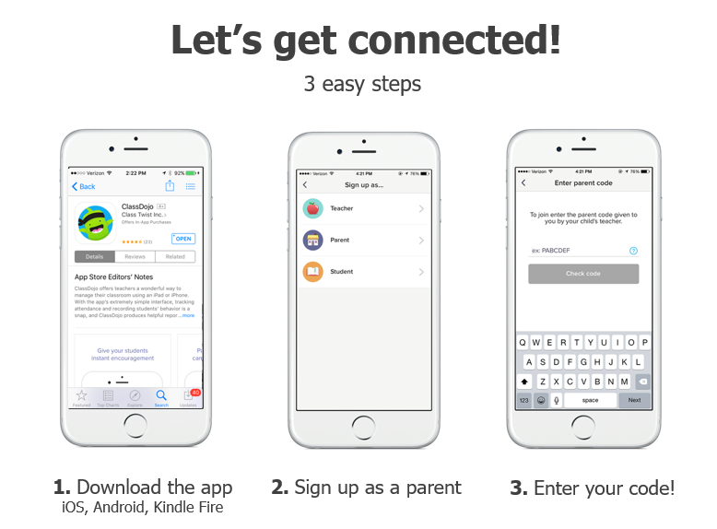
If you would like a second contact added, please contact the school office either by phone (01952 387720) or email (newdale.primary@taw.org.uk), and we will be happy to assist.
While Class Dojo offers a range of features, we will initially be focusing on:
- Awarding Dojo points
- Sending notifications of points earned to parents

As this is a new system for us, we may then introduce additional features gradually in the future.
We are excited to begin using Class Dojo and believe it will be a positive addition to our classrooms across the school.
If you have any questions or would like more information, please do not hesitate to get in touch.
Kind regards,

Miss Cook

